Google: search term 🡪 bureau of statistics us. Results:

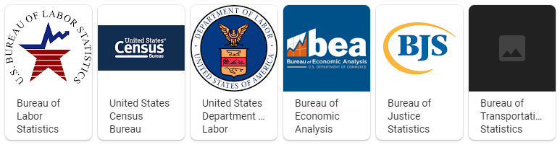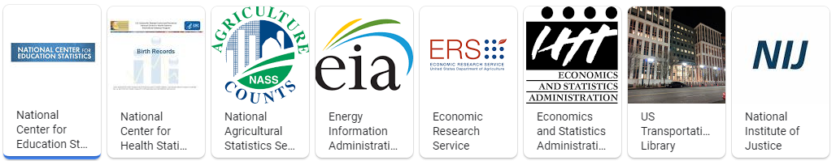



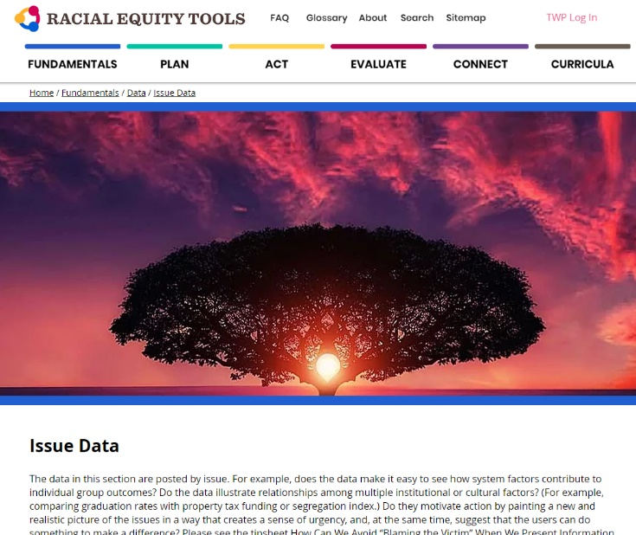The **National Center for Education Statistics** (**NCES**) is the part of the [United States Department of Education](https://en.wikipedia.org/wiki/United_States_Department_of_Education)'s [Institute of Education Sciences](https://en.wikipedia.org/wiki/Institute_of_Education_Sciences) (IES) that collects, analyzes, and publishes statistics on education and public school district finance information in the United States. It also conducts international comparisons of education statistics… NCES is a principal agency of the [U.S. Federal Statistical System](https://en.wikipedia.org/wiki/Federal_Statistical_System_of_the_United_States). (https://en.wikipedia.org/wiki/National\_Center\_for\_Education\_Statistics)

1. [https://www.racialequitytools.org/resources/  
   fundamentals/data/issue-data](https://www.racialequitytools.org/resources/fundamentals/data/issue-data) 🡪

[Is Your State Prioritizing Teacher Diversity & Equity?](https://edtrust.org/educator-diversity/" \t "_blank)

[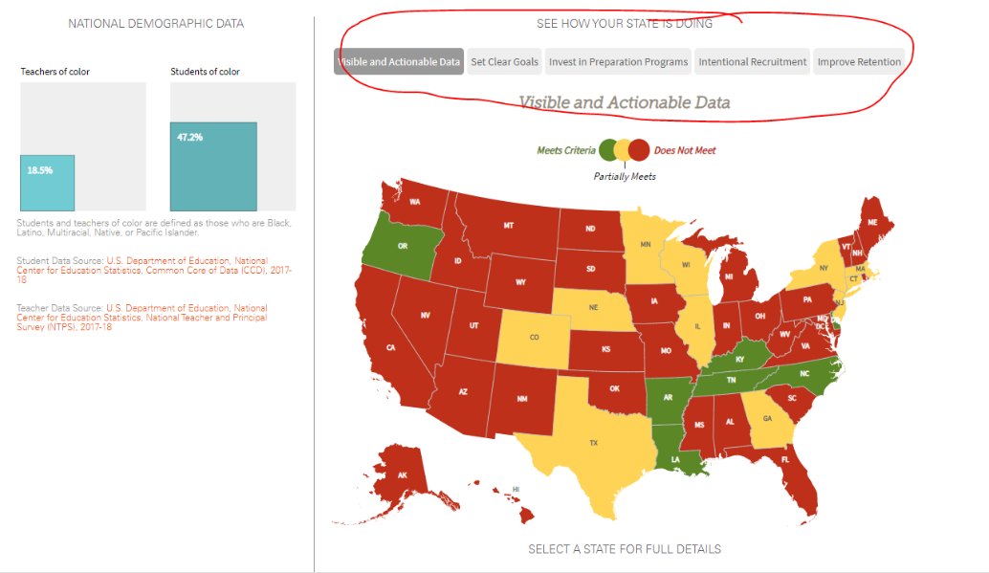](https://edtrust.org/educator-diversity/" \t "_blank)<https://edtrust.org/educator-diversity/>

Notice the 5 categories to view the data.

Each state is clickable.

1. <https://www.washingtonpost.com/graphics/2019/local/school-diversity-data/>

How the nation’s growing racial diversity is changing our schools  
By [Kate Rabinowitz](https://www.washingtonpost.com/people/kate-rabinowitz/), [Armand Emamdjomeh](https://www.washingtonpost.com/people/armand-emamdjomeh) and [Laura Meckler](https://www.washingtonpost.com/people/laura-meckler/) Sept. 12, 2019

Goto this page, be sure to scroll down. This image towards bottom of page. Then click the “Map: Explore your school district” link (bottom image).

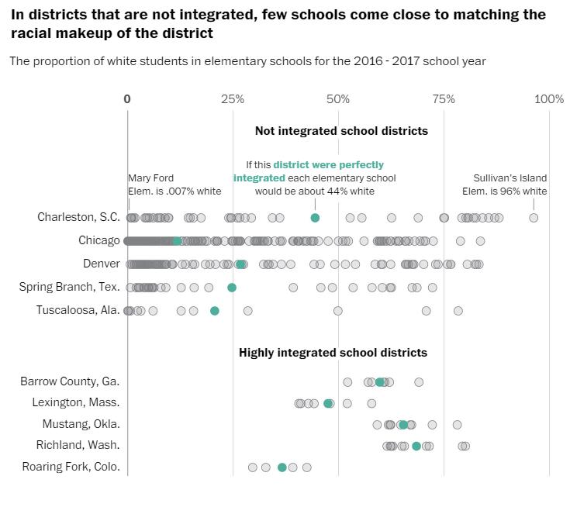

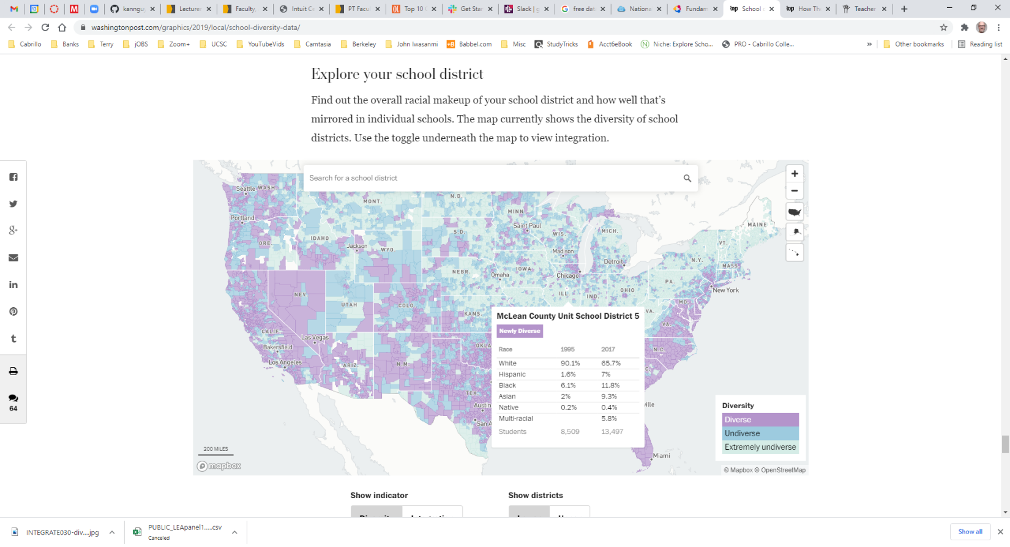



1. https://data.discriminology.org/search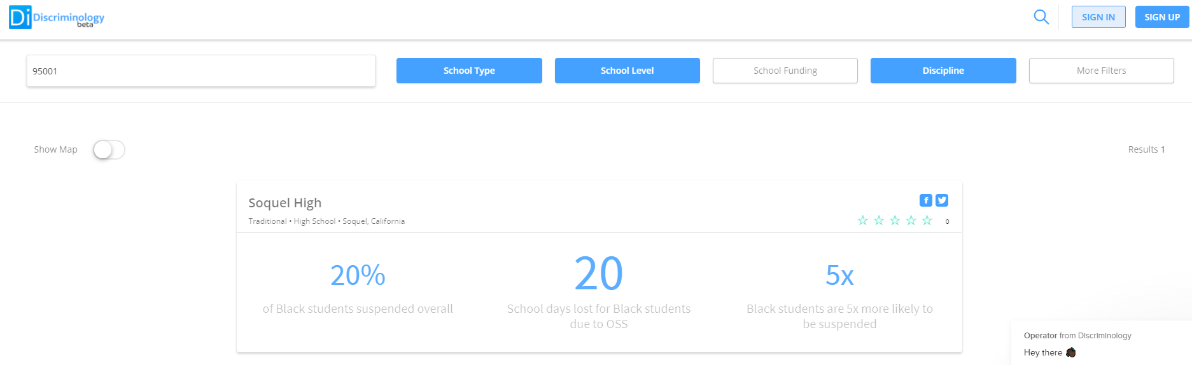



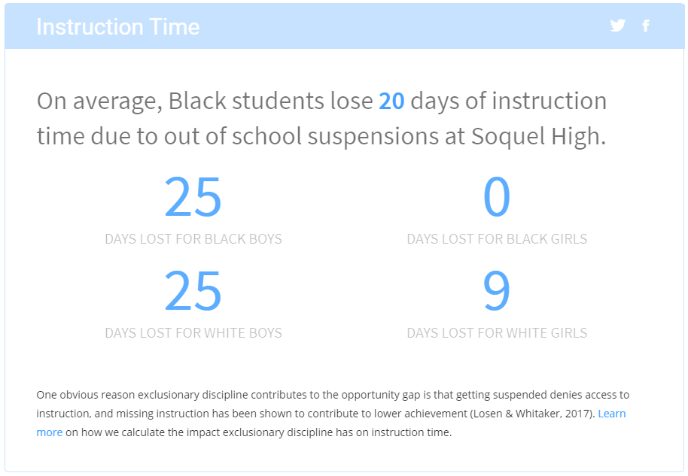

1. 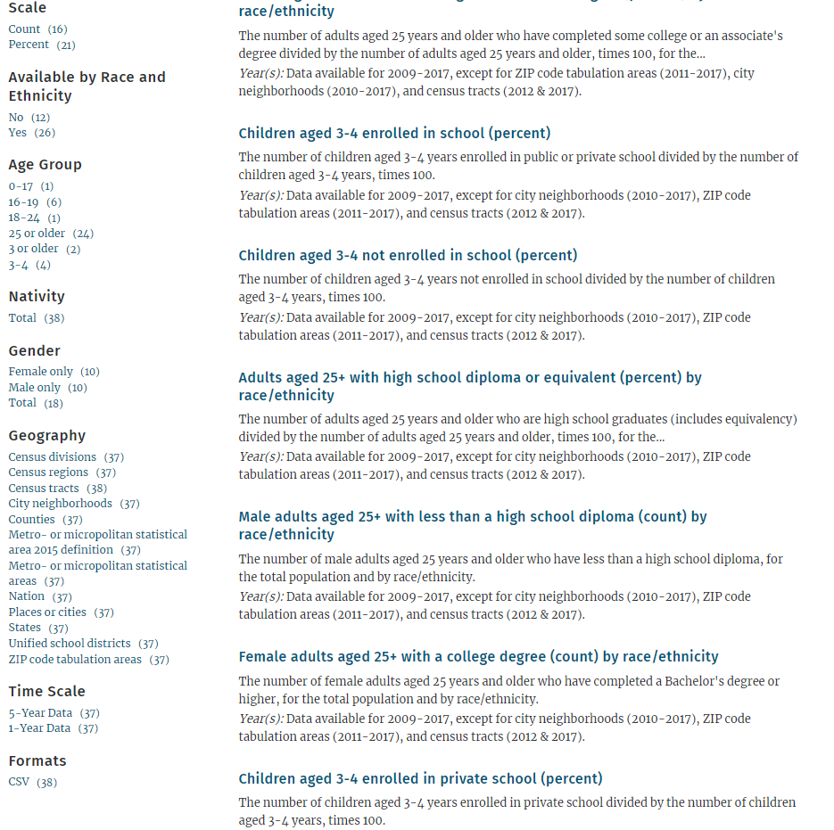<https://data.diversitydatakids.org/dataset?vocab_Topic=Education> This may be a good place to get data.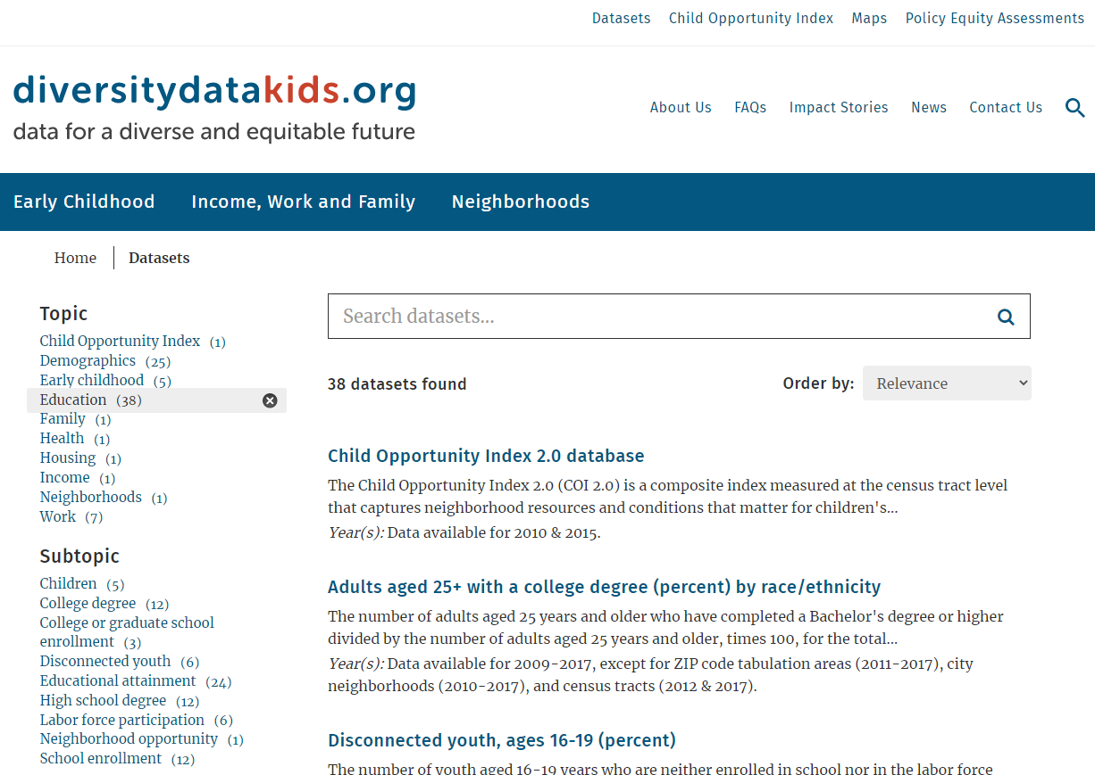



1. This is a good source: <http://datamart.cccco.edu/datamart.aspx>

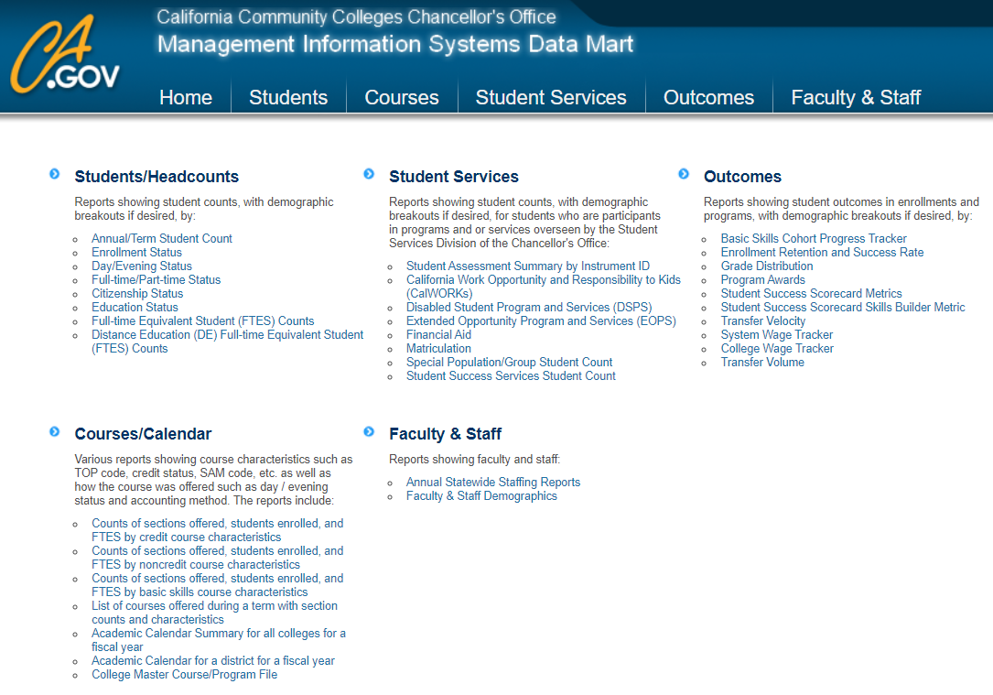It has enrollment, success, and completion data much with ethnicity for all the community colleges in CA. Data can be downloaded as csv's (avoid downloading in excel, it creates merged columns that are difficult to deal with).

1. Another dashboard set with downloadable data (especially SWP) is here: <https://www.calpassplus.org/LaunchBoard/Home.aspx>

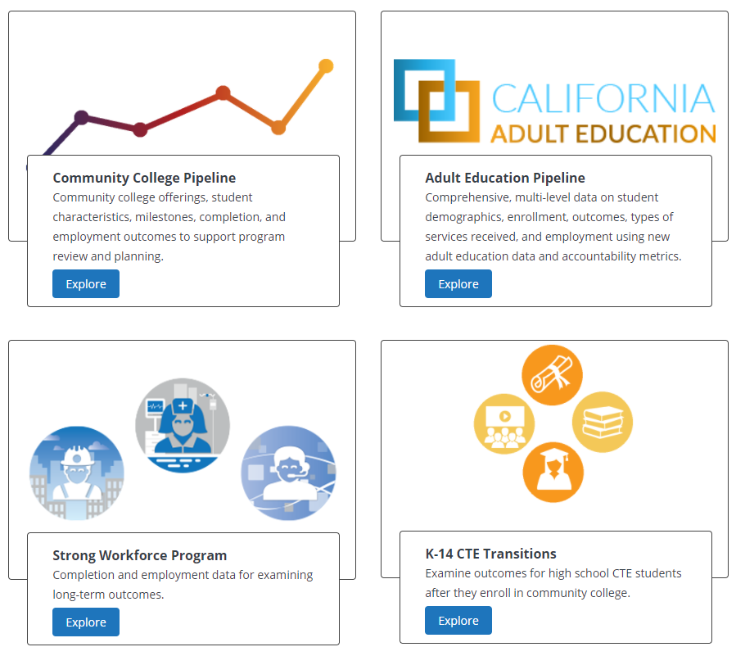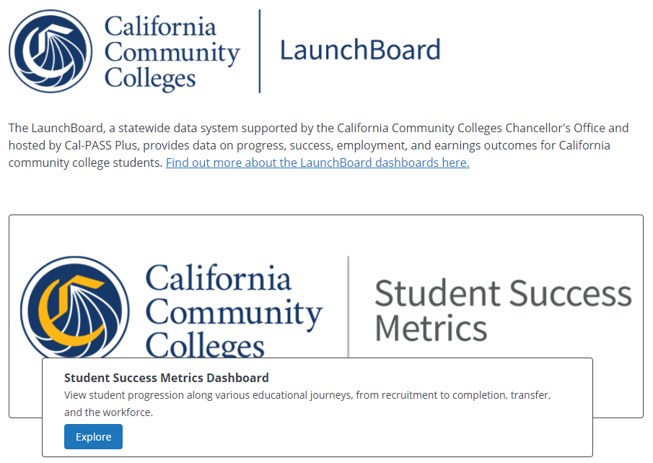  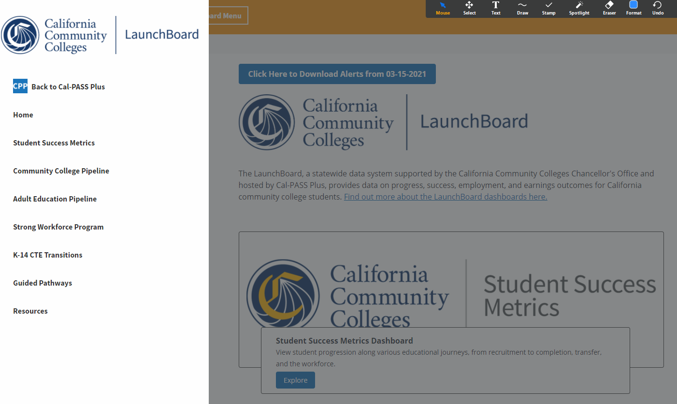







1. 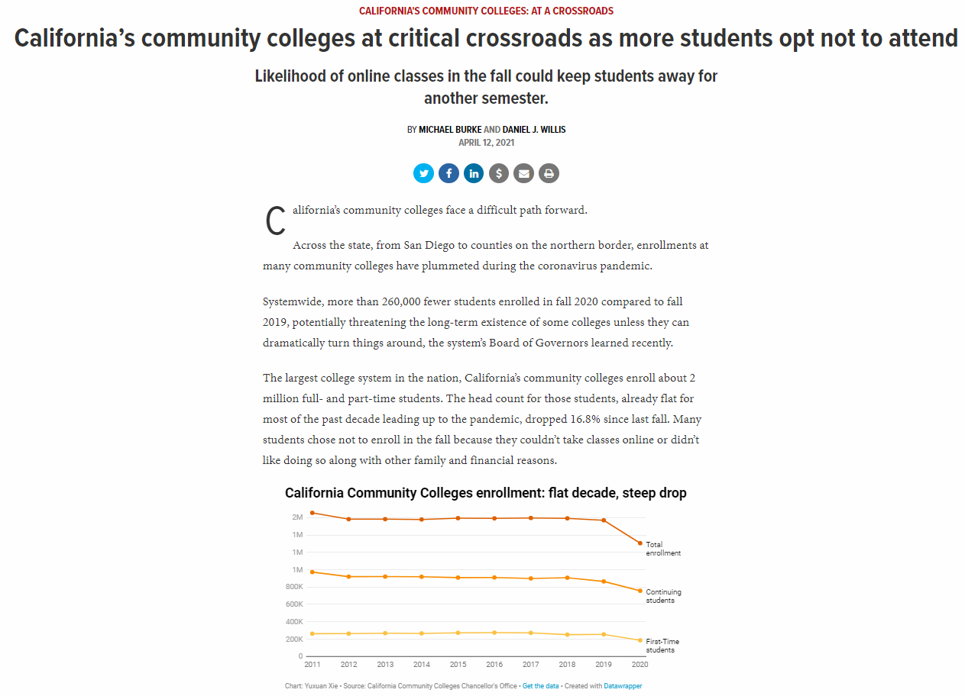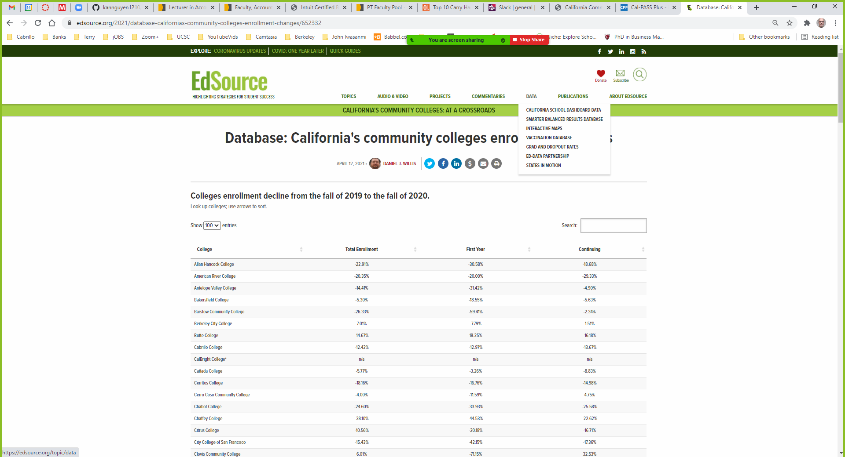Here is a recent article in EdSource that used the data mart to look at enrollment declines due to covid but it doesn't look like they examined drops by ethnicity: <https://edsource.org/2021/californias-community-colleges-at-critical-crossroads-as-more-students-opt-not-to-attend/652637#click=https://t.co/2ewiiNmr9p>

